Plan View

186 m

0 m

320 m

FBP X

FBP Y

FBP Z

FCS X

FCS Y

FCS Z

Fire line

Road

320 m

160 m

10 m x10 m

2 m x2 m

300 m

250 m

150 m

100 m

50 m

Devices

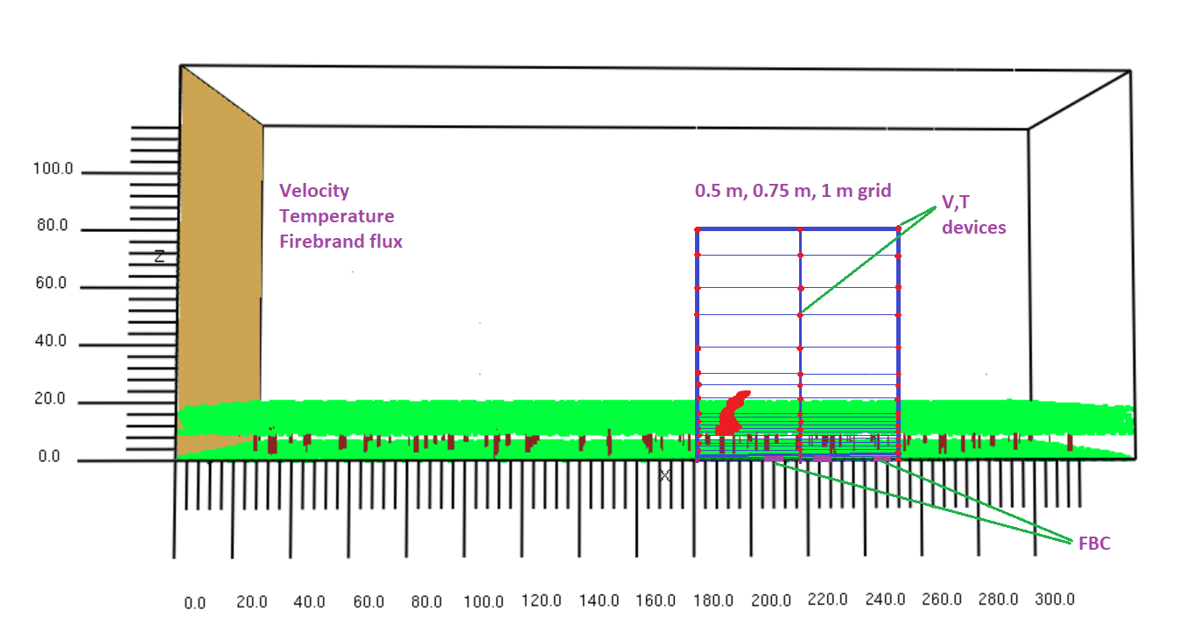

1. Graphical comparison of time-averaged temperature data

|  |
| --- |
| 500 mm grid |
| 750 mm grid |
| 1000 mm grid |

**Fireline is at x= 186 m

Only to 80 m height up to now. Please do it for 140 m height.

1. GCI based on time-averaged temperature data

|  |  |  |  |  |  |  |  |
| --- | --- | --- | --- | --- | --- | --- | --- |
| 200 m | | 215 m | | 245 m | | 260 m | |
| GCI(0.75/0.50) | GCI(1.00/0.75) | GCI(0.75/0.50) | GCI(1.00/0.75) | GCI(0.75/0.50) | GCI(1.00/0.75) | GCI(0.75/0.50) | GCI(1.00/0.75) |
| 54 | 116 | 86 | 181 | 132 | 60 | 55 | 53 |

1. Graphical comparison of time series temperature data

|  |
| --- |
| X= 182 m |
| X= 217 m |
| X= 252 m |

1. GCI based on time-series temperature data

|  |  |  |  |  |  |  |
| --- | --- | --- | --- | --- | --- | --- |
|  | GCI (0.75/0. 50) | | | GCI (1.00/0.75) | | |
| Height (m) | x=182 m | x=217 m | x=252 m | x=182 m | x=217 m | x=252 m |
| 0 | 15.2 | 17.8 | 14.0 | 35.4 | 42.4 | 24.6 |
| 5 | 27.63 | 82.0 | 8.3 | 12.4 | 51.8 | 14.2 |
| 10 | 11.44 | 154.6 | 18.7 | 19.6 | 340.8 | 21.5 |
| 15 | 20.79 | 174.3 | 33.6 | 33.1 | 309.0 | 133.1 |
| 20 | 9.40 | 214.1 | 44.5 | 20.3 | 525.2 | 99.4 |
| 30 | 8.03 | 681.0 | 93.8 | 10.4 | 955.7 | 128.3 |
| 40 | 9.57 | 792.7 | 352.2 | 5.9 | 1151.3 | 180.2 |
| 50 | 12.26 | 146.4 | 371.4 | 2.5 | 764.8 | 282.8 |
| 60 | 3.25 | 197.1 | 213.1 | 2.9 | 132.5 | 696.4 |
| 70 | 3.39 | 4.3 | 269.5 | 3.4 | 2.2 | 529.1 |
| 80 | 16.54 | 13.6 | 217.2 | 1.3 | 1.4 | 561.4 |

**Fire line height is 9 m above the ground

|  |
| --- |
|  |

1. GCI based on time-averaged temperature data

|  |  |  |  |  |  |
| --- | --- | --- | --- | --- | --- |
| Єrms | | | **GCI (0.50/0.75)** | | |
| x=182 m | x= 217 m | x=252 m | x=182 m | x= 217 m | x=252 m |
| 0.053975 | 2.316011 | 0.079631 | 13.7 | 38.2 | 26.8 |

|  |  |  |  |  |  |
| --- | --- | --- | --- | --- | --- |
| Єrms | | | **GCI (0.75/1.00)** | | |
| x=182 m | x= 217 m | x=252 m | x=182 m | x= 217 m | x=252 m |
| 0.039417 | 0.243196 | 0.085645 | 16.2 | 53.0 | 30.4 |

**\*\*Currently doing the MATLAB plotting for different locations.**

Firebrand flux

Number of firebrands collected

|  |  |  |  |  |
| --- | --- | --- | --- | --- |
|  | 750 mm grid | | 1000 mm grid | |
|  | 100 m2 | 4 m2 | 100 m2 | 4 m2 |
| FCS X | 139 | 8 | 183 | 13 |
| FCS Y | 1258 | 316 | 2367 | 488 |
| FCS Z | 4565 | 200 | 3475 | 177 |
| total | 5962 | 524 | 6025 | 678 |
| difference | 1.04% | 22% |  |  |

Firebrand flux

|  |  |  |  |  |  |
| --- | --- | --- | --- | --- | --- |
|  | 750 mm grid | | 1000 mm grid | | Experiment  (pcs/m2s) |
|  | 100 m2 | 4 m2 | 100 m2 | 4 m2 |
| FCS X | 0.0420 | 0.0644 | 0.0350 | 0.0500 | 0.824 |
| FCS Y | 0.3308 | 2.1345(?) | 0.6272 | 3.3685(?) | 0.902 |
| FCS Z | 1.1134 | 1.2496 | 0.9399 | 1.1384 | 1.361 |

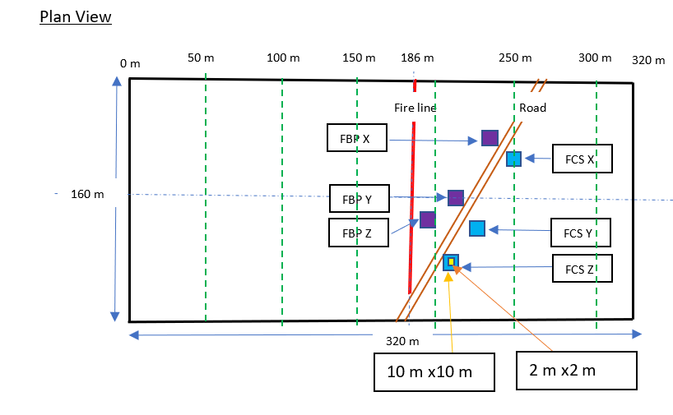

Firebrand mass vs projected area analysis with Babak Bahrani’s findings.

|  |  |
| --- | --- |
| Babak Bahran’s firebrands | Alex Filkov’s firebrands |

|  |  |  |  |
| --- | --- | --- | --- |
| Babak’s experiment | | Filkov’s experiment (all firebrands) | |
|  | Firebrands % |  | Firebrands % |
| Projected area < 3 cm2 | 88 | Projected area < 3 cm2 | 93 |
| Projected area < 1 cm2 | 74 |
| Mass < 1g | 98 | Mass < 1g | 60 |
| Mass < 2g | 84 |

|  |  |  |  |
| --- | --- | --- | --- |
|  | cylinder | sphere | cube |
| Projected area < 3 cm2 | 95 | 100 | 87 |
| Projected area < 1 cm2 | 74 | 88 | 73 |
| Mass < 1g | 74 | 38 | 74 |
| Mass < 2g | 95 | 88 | 80 |

Mechanism of measuring mass and projected area.

* Projected area:
  + measured using SketchAndCalc tool (images provided).
* Mass:
  + Firebrands dimensions were measured using SketchAndCalc tool (images provided).
  + Element density of canopy woody fuels = 512 kg/m3. Firebrands temerature 60-100C and some are 147C. Assume moisture evapotated and the density is 354 kg/m3 [Thesis Table 7.1 Muller et al]
  + For cubic shape firebrand thickness [Experimental Procedures Characterising Firebrand Generation in Wildland Fires, El Houssami Muller et al 2015 (1-6 mm)]
  + Element density of canopy woody fuels = 512 kg/m3. Firebrands temerature 60-100C and some are 147C. Assume moisture evapotated and the density is 354 kg/m3 [Thesis Table 7.1 Muller et al]

m=v.ρ

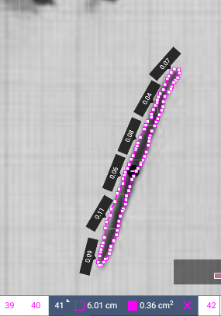

Firebrand mass vs projected area analysis with Babak Bahrani’s findings.

The developed predictive model,

mass

slope

Estimated error

intercept

Projected area

|  |  |
| --- | --- |
|  | |
|  |  |
|  |  |

|  |  |  |  |
| --- | --- | --- | --- |
| **firebrand** | | **Intercept** | **slope** |
| All firebrands | | -0.3956 | 1.257 |
| Cylinder | | 0.1159 | 1.5327 |
| Cube | | -0.9666 | 1.0 |
| sphere | | 0.4327 | 1.5 |
| *Loblolly pine (Idle wind)* | | *-3.12* | *1.49* |
| *Saw palmetto* | *Idle (5.36 m/s)* | *-3.65* | *1.17* |
| *Medium (11.17 m/s)* | *-3.10* | *1.08* |
| *High (17.88 m/s)* | *-3.66* | *1.43* |

